

Service Desk Manual

Written by the members of the Reiver service desk





Contents

Mission Statement 0

Procedures performed 1

BACKUP POLICY 9

Customer Communication Policy 11

Customer Processing 12

SERVICE DESK EMAIL POLICY 13

Policy for tickets 14

Help Desk Instructions and Troubleshooting 16

Security policy 18

SLA 19

Customer Satisfaction Survey 20

Tech Checklist 21

USER/STAFF TRAINING PLAN 22

Work Policy and Procedure 23

Safety Practices 24

Asset Management 25

Ticket System Manual 26

Outside Sources Cited 29

# Mission Statement

Our mission at the Reiver help desk is to deliver extensive support and to meet and exceed the expectations of our customers. The Reiver help desk prides itself on fulfilling the needs of others and delivering this service with a smile.

We will achieve this by:

* Laying out clearly defined expectations
* Offering extensive support at first contact
* Offering multiple points of contact
* Working to continually satisfy our customers

**Policy**

We have a clearly defined set of policies that our staff take pride in abiding by and fulfilling.

**Goals**

The goals of all our staff is to meet and exceed the expectations of our customers and to provide them with the services that they deserve.

**Purpose**

We are to be the single point of contact for all IT related incidents on campus.

## Procedures performed

The following is some individual procedures performed by the service desk and detailed outlines on how they are done.

***Virus removal***

By far the most reported incident in the service desk is of a virus or some sort of malware on a client’s computer. The cause of a virus can vary, but asking the customer about his browsing habits can help in teaching them about prevention of future incidents. Remember that all data must be backed up before proceeding.

The standard procedure for virus removal goes as follows:

1. Download an antivirus executable onto a flash drive or other medium.



A popular antivirus tool that the help desk likes to use is MalwareBytes. Go to [www.malwarebytes.com](http://www.malwarebytes.com) and download the executable. Put the executable on a flash drive or other portable medium

1. Boot the problem computer into safe mode.

An easy method of going into safe mode is by running msconfig.exe and enabling safe mode on next boot followed by a restart into safe mode

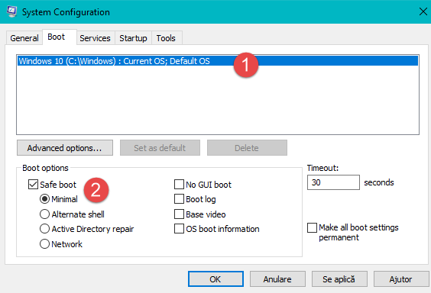

Another way of doing this is to hit restart while holding the shift key, which in turn will bring you to an option page.

When on the option page follow this combination of settings: Troubleshoot🡪Advanced Options🡪Startup settings. You can then select the safe mode option which will be represented by a number. This will bring up safe mode on the next boot.

1. Once in safe mode plug in your removable media and install the antivirus. Run the antivirus while in safe mode and try to remove the virus. Be sure to restart and verify that the virus has been removed.

Sometimes a virus cannot be removed this way. And requires more intrusive methods. One such method is to install an AV live medium to a flash drive and boot into it. A favorite of the help desk is the Kaspersky live antivirus medium

1. To find the ISO image and the installer go to <https://support.kaspersky.com/8092#block2> and follow the instructions to the links in the manual.

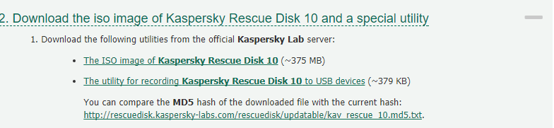

1. After downloading both utilities you need to install the utility for recording the Kaspersky Rescue Disk 10 OS. Install the utility and open it.
2. 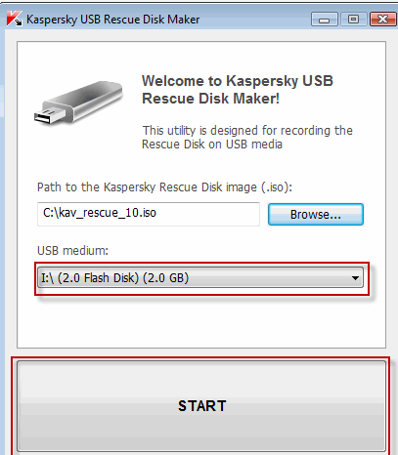

First you click browse, find your ISO file, select your USB medium, and allow it to image the disk.

1. You must then restart the machine and enable boot from removable disk from the BIO’s or UEFI. Be sure to have the flash drive plugged in before the computer POSTs.
2. You will boot into Kaspersky Rescue Disk 10, which navigating shouldn’t be too difficult if you are familiar with Linux. Enable the GUI interface and open the rescue disk program preinstalled to the OS.

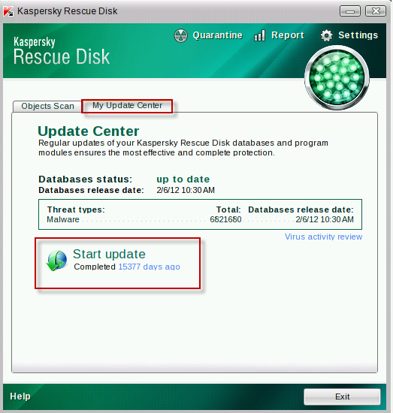

It is extremely important that you update the databases before proceeding with the scan.

1. Finally click on objects scan, select your Windows Partition and scan it for Malware. Remove the viruses and attempt to boot back into windows.

***Screen Repair***

Laptop screen repair can cover a very broad spectrum because of the amounts of proprietary systems that exist with laptop manufacturers. This procedure will vary by the model of your laptop but this broad overview will give you a basic idea of what to do when going about it. Be sure to look up online guides when performing this procedure and back up all data before fumbling inside the laptop.

1. The first step in doing any work to an electrical device is to remove the power source. Unplug the battery and any power connectors and hold the power button to drain any excess electrical power. Be sure to discharge yourself of any static electricity before proceeding.

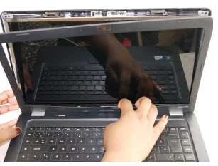

Usually laptops have removable bezels, and most HP and dell laptop bezels can pop right off to expose the screen. On some laptops you may be required to remove some screws or even take the bottom or the keyboard off but this is manufacturer dependent.

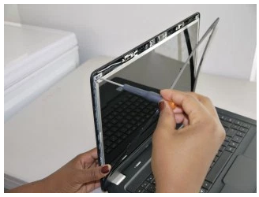

After the screen has been exposed you need to remove the screws holding the screen into place. The bezel may be still hanging or completely off the hinge but either way try not to damage it. Most screens have 4 screws with one in each corner of the screen.

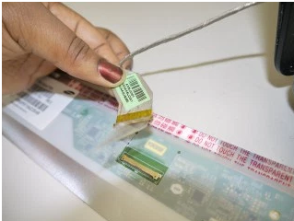

After removal of the screen you will notice that it’s attached by a small connector covered by a piece of tape. Remember that this is manufacturer specific but this is what you will see in most cases. Peel back the tape and firmly pull the connector straight out of its socket.

1. Now it’s time to replace the screen. Follow the steps in reverse and replace the broken screen. Don’t forget to firmly attach the connector to the new laptop and to reattach the tape that covers the connector.

***Installing an OS***

Many times when working in the service desk you may find yourself needing to fix a broken copy of windows or any other operating system. A good surefire way of fixing computers is to back up user data and reinstalling the OS. The following procedure is recommended for the service desk and covers a standard windows 10 installation

1. First you need to obtain an ISO and make it bootable. This can be done on a DVD, flash drive, or even a flash card. There are many ways to do this and that falls out of the scope of this procedure but there are many online guides outlining how to do this.
2. To boot from the medium you need to set your UEFI/BIO’s to boot from it. This can be done by pressing the manufacturer keystrokes and getting into your motherboard firmware settings. Usually this setting will be called boot priority. Set the priority and restart the machine with your medium plugged into the machine.
3. Boot into the OS, which could be a windows or Linux OS, depending on what you are installing. The standard service desk procedure outlines a standard Windows 10 installation.

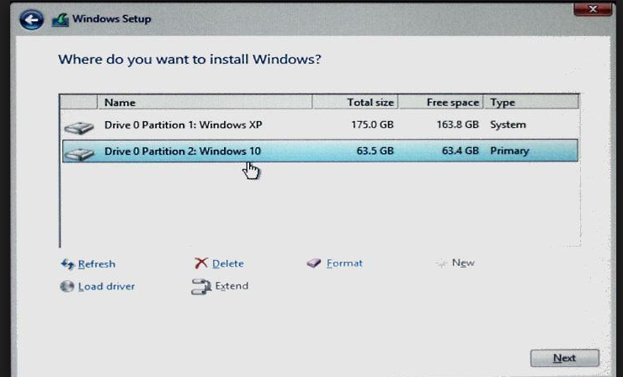

You will come to a page that looks like the following example. You will need to set up your partitions depending on how you want your computer set up. The example shows a dual boot configuration of 2 operating systems. If you are only installing 1 dedicated OS then use the entire allocated space for a partition.

1. You will then hit next and wait for the system to install itself. Be sure when the system restarts afterwards it boots off the hard drive and not the live medium. You must then set up user accounts, settings, and policies. Use default windows settings and install programs based on customers’ requests.

***General inquiry***

For general inquiries and requests, you should follow this basic procedure. Inquiries can include installing software, updating programs, removing software, changing passwords, or training the customer. These requests are often quick and don’t usually require one to drop off their device for a later date.

1. Greet the customer with a standard professional greeting and ask them about their issue or request.
2. Have the customer fill out a ticket request while you create the ticket in the online ticket system.
3. Preform the specified task and inform the customer on any changes that you have made.
4. Ensure customer satisfaction. Make sure that all your changes are to the request of the customer and that his needs have been satisfied accordingly.

These general procedures may not outline all the procedures of the desk and you may be asked to fulfil a request outside the scope of this Manual. This can be considered normal and is up to the discretion of the person running the desk. You may receive requests outside the scope of the service desk and it is up to you to decide if you take these tickets or not.

# BACKUP POLICY

In some instances, such as certain virus infections, the only software repair option available for your computer may be to reformat the hard drive. Reformatting the hard drive means completely erasing all data on your computer and performing a clean install of the operating system. In any instance where the computer is going to be reformatted by the IT Help Desk, all data should be backed up. Regardless of the circumstances however, it is always standard procedure that all data be backed up before any changes are made to the installation.

Customers can also opt to have the Help Desk back up a certain amount of school-related data for you. The Help Desk can back up certain school related data of great importance for customers. This data may be placed in a folder on your desktop called “Backup” or something else easily recognizable. We can also create system images for external drives if the customer ops to go that route. (If you are not able to back up your data because your computer won’t boot up, the Help Desk can attempt to find your data in another location)

**Files that the Help Desk will back up include, but are not limited to:**

* Documents
* Spreadsheets
* Databases
* Digital camera pictures
* Graphic design work
* PDF files

The Help Desk is not able to migrate or otherwise back up any currently installed applications or system settings to the reformatted operating system. You are responsible for re-installing all programs and setting privacy and system settings.

***Note:*** *Data backup is a standard policy in the service desk and IT will make every effort to do so but cannot guarantee that any or all data will be successfully backed up.*

*The Reiver service desk is available for the community and is a free student run help desk.*

# Customer Communication Policy

IWCC has formal procedures in place to ensure the authenticity and security of customer communications.

The service desk may contact you for reasons such as:

* We have an update on your ticket
* We request additional parts for the current ticket
* There were complications in resolving the ticket
* We have resolved your ticket

Only designated team members are authorized to contact customers. We do not share customer contact information, or personal information recovered with third parties. Any unsolicited communications from other than a recognized account team should be immediately reported to IWCC. E-mail communications from IWCC employees can be easily identified as coming from “@iwcc.edu”.

Any other e-mail source should be treated with suspicion as it may contain malware or a form of virus, which may lead to an unwanted result of your personal security or computer performance. If you have any questions regarding this policy or believe you have received an informal form of communication, please contact the help desk at IWCC immediately.

# Customer Processing

1. When customer walks through door, associate will greet them with professional greeting.
2. Associate needs to identify the problem. Ask them what’s wrong with their device.
3. Get the details. Ask them what they were doing before it happened? Has it been damaged or dropped recently? Do they have a warranty?
4. Get their information. Fill out their ticket and double check to make sure all info is correct.
5. Make sure you have what you need. Computer, battery, and charging cable all need to be checked in.
6. Give them a rough estimate of when the device will be finished. If you are unsure, saying a larger amount of time is always better than saying a smaller amount of time.
7. Check out customer. If it’s a basic procedure like removing a virus, you can give a price estimation, but double check with them to make sure all contact info is correct,
8. Give them a professional goodbye and start working on machine.

Continue with process

Recommend they send it back to manufacturer

Yes No

Is it a hardware issue?

Make sure you have all that you need. (Computer, battery, charging cable, etc.)

Yes No

Is it under warranty?

Identify Problem

Get customers information and fill out ticket

Check out customer and give a rough estimation of time/price if asked

# SERVICE DESK EMAIL POLICY

**LEGAL IMPLICATIONS –**

Email is meant to be used as an effective business tool only. Email will be used in an effective and lawful manner. Please be aware of the following legal implications.

* If you send an email with any defamatory, offensive, racist or obscene remarks, you and the service desk may be held liable to legal action.
* If you forward an email with any defamatory, offensive, racist or obscene remarks, you and the service desk may be held liable to legal action.
* If you forward or send any confidential information without the customers’ consent over email, you and the service desk can be held liable to legal action.
* If you forward an email that contains a virus, you and the service desk can be held liable to legal action.
* Email is discoverable in a court of law, and can be used as evidence. There is no presumption of confidentially or privileged communication.

**EMAIL POLICY –**

Email is a limited resource and extreme care should be taken to minimize the size and number of attachments that are sent. No contact information for customers shall ever leave the service desk for any reason. All attachments should have a legitimate business purpose. Email with graphics or colored backgrounds require far more resources than plain emails and should not be used for business correspondence. Due to the possibility of viruses sent via email in attachments, virus scanning software should be kept current. Although the firewall scans for viruses and attachments with malicious intent, an individual who forwards a known virus into or within the service desk may have their email account deactivated, may be subject or legal actions, and may face termination.

# Policy for tickets

The service desk operates as a small centralized service desk. All operations are to take place in the lab room in the Freemont building and incidents are to remain inside the service desk.

Students receive tickets as they come in and the assigned technician assumes responsibility for the incident. Tickets can be reassigned as technicians come in to work as technicians do not always work every day. Incidents must be verified as fixed before being returned to the owner.

The incident management process follows the ITIL recommended procedure for handling incidents and goes as follows:

1. Incident identification
2. Incident logging
3. Incident categorization
4. Incident prioritization
5. Incident response

All tickets that go into the desk follows this procedure.

***Incident identification***

Identification of tickets include categorizing them as an incident or a request. Requests can often be fulfilled upon receiving them but be sure to summit a ticket for logging purposes. Once an incident has been identified you may go about submitting a ticket as described before in this manual.

***Incident logging***

Logging incidents is a very important part of keeping up to date with tickets and helping other members of the desk in solving the incident. Information submitted in a ticket should include a name, some methods of contact, information on the incident or request, and the time of the incident submission. The customer should also fill out a ticket form and a waiver.

***Incident categorization***

Categorizing incidents helps the service desk better understand the problem and more quickly decide on troubleshooting methods. Categorization includes power issues, certain hardware issues, certain software issues, viruses, backups and ext. Categorization can be mostly broad in this desk but it does help to determine incident priority

***Incident prioritization***

In this service desk priority is mostly determined by the time a ticket has been out. Longer outstanding tickets take the most priority over others. Priority is also factored in the impact to users and the desk but, because of the scope of the student run desk it’s mostly determined by time.

***Incident response***

Incident response is the most important and the longest part of this process. This includes diagnosing and troubleshooting the incident as well as resolving and closing the incident. It is always best practice according to ITIL in having a backup and recovery system. Always back up data before working on a machine. All work along the way should be documented and users should collude on tickets as to not interfere with others work.

# Help Desk Instructions and Troubleshooting

Troubleshooting can often be a long tedious process therefore having a guide to help along the way is always best practice. Incidents can be unexpected and not everything defined in this guide can help in every ticket however this general overview will help guide you on your basic troubleshooting needs. Remember that all data should be backed up before any troubleshooting is done.

***Policy on Software***

Our service desk does not have any policies on specific software to be used however, this guide will list some helpful software recommendations for customer’s needs.

Office tools: Microsoft office suite (if a student with access to the software), libre office, google docs.

Media Players: VLC,KMPlayer, Windows media player.

Antivirus: Avast, AVG, MalwareBytes.

Web browsers: Firefox, Google Chrome, Internet explorer, safari.  
Some other helpful software includes Rufus, Putty, Speccy, HW monitor, psensor, prime95, and UNetbootin.

***Windows 10 slow computer troubleshooting***

The best thing to do in the case of a slow computer running windows is to open task manager and check if there are any resource heavy tasks taking up processing time. Processes like this can not only hog the CPU but also be heavily impacting the HDD as well.

If the HDD is being hogged the first troubleshooting activity and the simplest one is to defrag it. This is the most basic activity but is a nice thing to get out of the way. The next step is to see what resources are hogging the HDD, and if they can be disabled. If the services are windows based, then an online search is your next best route. Some common windows tasks that take up HDD time is windows search, windows SuperFetch, and windows antivirus.

To disable windows search to troubleshoot and rule out that as an issue you must first open a command prompt with administrative privileges. Run the command ‘net.exe stop “windows search”’. This is only temporary and is a way to see if it speeds up HDD times. You can disable this service in the services.msc program.

To disable SuperFetch, you can run ‘net.exe stop SuperFetch’ in an elevated command prompt. Troubleshoot and see if this improves performance any.

Another HDD troubleshooting method is the check disk program. Run ‘chkdsk.exe /f /r’ in an elevated command prompt to check the integrity of your hard drive.

A big resource hog in windows systems can be antivirus programs. Consider disabling antivirus programs in windows to troubleshoot the possible causes of HDD slowdowns.

These troubleshoots are rough and often you might have to go online to get new tips and information on finding problems. Often google is your friend.

***Virus Removal***

The policy for removing a virus can vary based on the virus installed. The best go to method is boot into safe mode and install an antivirus such as Malwarebytes. Booting into safe mode hopefully prevents the virus from running. Install and run the antivirus and try to remove the virus. Sometimes multiple viruses can be on the machine and can take multiple antivirus software’s to remove. In a worst-case scenario, you may need to completely reinstall windows and start from scratch. In this case make sure to back up the old data onto another drive for recovery of files before formatting it. A great way for fixing an extremely infected machine is running a live AV boot disk. Kaspersky makes a great Linux based boot disk that you can use to recover data from an infected hard drive.

***Screen replacement/HDD replacement***

Before replacing any screens make sure to verify that the screen is the culprit of the problem. You will need to ask permission from the customer and have them purchase a screen for replacement. Be sure that the customer has signed the waiver and all their data has been backed up. Remember that all laptops are proprietary and that you will need to look up a guide to get step by step instructions on fixing the screen. Replace the screen and verify the fix. Be sure not to break any components or introduce static electricity to any components in the machine. For hard drives, be sure to back up any data as needed and transfer it over if requested. Take the back panel off the laptop and replace the drive. You will most likely need to look up a guide in doing so. Be aware that not all parts in laptops are user serviceable. For desktop computers, replacing a CPU, HDD, or GPU can be pretty straight forward an most online guides can accommodate for your needs.

# Security policy

Any data found on a customer’s computer is to remain the sole property of them henceforth no data of a customers should be copied or stolen for personal use by any technicians. This includes but is not limited to pictures, word documents, private software, multimedia, or emails. Files may be backed up locally for storage and work-related purposes but must be terminated after the closure and resolution of the incident. Laptops or hardware are also to be locked up and secured upon closure of the help desk for security of the customers assets.

# SLA

**Service Desk**

**Service Level Agreement**

This Service Level Agreement (SLA) applies to the service desk and its customers. The purpose of this SLA is to inform the customer what services and promises Information Technology offers. This SLA also covers IT’s expectations of its customers to ensure speedy and accurate resolutions.

This SLA explains the following:

* **Service Desk should commit to provide the best customer experience when possible**
* **Provide hours of operation and times of availability**
* **How to contact the service desk**
* **Promised response and resolution times**
* **Customer responsibilities**

The Service Desk aims to provide the best experience possible to ensure 100% complete customers satisfaction. The Service Desk should commit to provide the best customer experience.

**Hours:** The Service Desk is open 7:30 a.m. – 7 p.m. Monday – Friday during normal business days. Summer hours are typically 8 a.m. – 4:30 p.m.

**Contact methods:** Customers can contact the Service Desk using the following methods:

* **Fill out and submit a ticket online using the portal**
* **Email:** [**servicedesk@notarealemail.com**](mailto:servicedesk@notarealemail.com)
* **Telephone: 712-123-4567**

**Response Time:** Response times fit within the hours of operations stated above.

**Resolution Time:** Resolution times vary from incident to incident. Times estimated will be provided by the tech who has taken responsibility. We strive to resolve the incident as soon as possible but are not always guaranteed.

**Customer Responsibilities:** Creating a ticket starts a conversation with the goal of resolving an issue.

* Provide detailed information regarding the issue. For example, include the web address or specific location of hardware (building, room number, location in room)
* Information not provided can impact the tech’s ability to resolve the incident in a timely manner
* Make every effort to be available to communicate with the tech.
* Make use of the Service Desk articles
* Check the Service Desk portal for notifications

**This agreement has been evaluated and will be modified as needed through the end of the contract.**

# Customer Satisfaction Survey

***The following survey is to be handed out during the resolution of all tickets.***

*We want to know what you think! Please provide feedback on your experience and help us improve our service.*

**On a scale of 1 – 5, 1 being low and 5 being high, please rate the following.**

*(Use NA for any question that is not applicable*)

**____The availability of help desk staff and your ability to reach them in a timely manner?**

**____The speed in which your question or incident was resolved?**

**____The timeliness of updates regarding the status of your issue?**

**____The quality of service you received?**

**____The friendliness of the analyst(s) that assisted you?**

**____The overall service you received?**

**Do you have any extra comments, suggestions, or concerns?**

**____________________________________________________________________________ ______**

**__________________________________________________________________________________________________________________________________________________________________________**

**If you would like to be contacted again by a manager, please provide an email or phone number below. (Optional)**

**Email ______________________________________________________________________**

**Phone number ______________________________________________________________**

# Tech Checklist

The tech checklist goes over all the needed procedures to run a smooth and productive service desk.

* Is all needed workplace equipment on and running correctly?
* Is external memory available for backing up files Such as Hard drives and memory cards?
* Does every laptop have the appropriate charger?
* Is all antivirus running correctly?
* Make sure that the main door is unlocked
* Is the open sign in the door notifying students that you are ready to provide support?

**If all the necessary equipment isn’t available, then the course instructor should be immediately notified.**

# USER/STAFF TRAINING PLAN

Every new staff member will need to be trained in the appropriate manner –

* Give the new staff member a formal tour of the workplace and ensure that he/she knows where to find or receive all tools needed to do the job accordingly
* Ensure the new staff member knows how the phone system works
* Get the new staff member accommodated with the emailing system
* Review procedures with staff member for using email
* Go over the tech checklist
* Show staff member what duties need to be completed, both at beginning and end of shift.
* Teach new staff member how the ticketing system works
* The new staff member assigned to you should “shadow” a current tech for at least twenty working hours.
* The new staff member shall be “shadowed” by its trainer for twenty working hours.
* Have new staff member study the manual for procedures.
* The staff member will be tested on work procedures to ensure that he/she is familiar with the businesses goals and scope of work.

# Work Policy and Procedure

Policy

This policy establishes the work expectations of the service desk. All current employees are expected to work the hours they have previously scheduled. Failure to work these hours can lead to termination.

Procedure

The service desk is a free work experience class run by IWCC students and they are expected to show up to earn their credits for the class.

Employees are expected to work their regular scheduled shift.

Time Reporting

Each department is responsible for maintaining accurate time and attendance records. For each non-exempt employee, a time record must be completed for each day and submitted.

Non-exempt employees are required to:

Report actual time worked.

Take an uninterrupted meal break of at least 30 minutes if working 6 or more hours

Accurately record meal break.

I. Absent

An employee is deemed absent when he/she is unavailable for work as assigned/scheduled and such time off was not scheduled/approved in advance as required by department notification procedure.

Failure to report an absence in advance can lead to possible termination. Employees are allowed 5 personal days a year. Supervisors should monitor their employees' attendance on a regular basis and address unsatisfactory attendance in a timely and consistent manner.

# Safety Practices

Employers are responsible for ensuring their workers know the safest way to do their work. This includes knowing the hazards of their jobs and their workplace and knowing how to control these hazards.

* All work should be done using the appropriate work equipment
* Inspect all equipment before using it to make sure it is in safe and working order.
* Work should be done in the approved way, to reduce the change of injury or strain.
* Workers are allowed short breaks from typing or using a mouse to avoid Repetitive strain injuries.

# Asset Management

Tools

At the help desk you have plenty of tools at your disposal. Some things you’ll use daily and some things you’ll find that you will never use. There are always basic tool kits sitting at the end of each table. Inside are several different screw drivers, a bottle of screws, tweezers, extractors, and various other tools. There are certain tools to test batteries, hard drives, cables, and plenty of other devices but these are not used as much. There are also cabinets with assorted tools like mallets, plyers, and drills.

Security

The security involves keeping all things locked. All cabinets containing machines and important material should be locked whenever there is not a worker around and when you close down. Both WiFi’s are password protected as well as having WPA2 encryption. All administrator accounts for the ticket management website are password protected and need to be logged out of when done.

# Ticket System Manual

*This manual explains how to navigate throughout the ticket program and will show you how to open and close tickets, set up users, send emails, and FAQ*

*The ticketing system for the help desk can be found at* <https://pcsupport.ecc.iwcc.edu/scp>*.*

1. First step in creating a ticket is creating the user. This is for putting down the customers information and making them their own account. It will look similar to this:

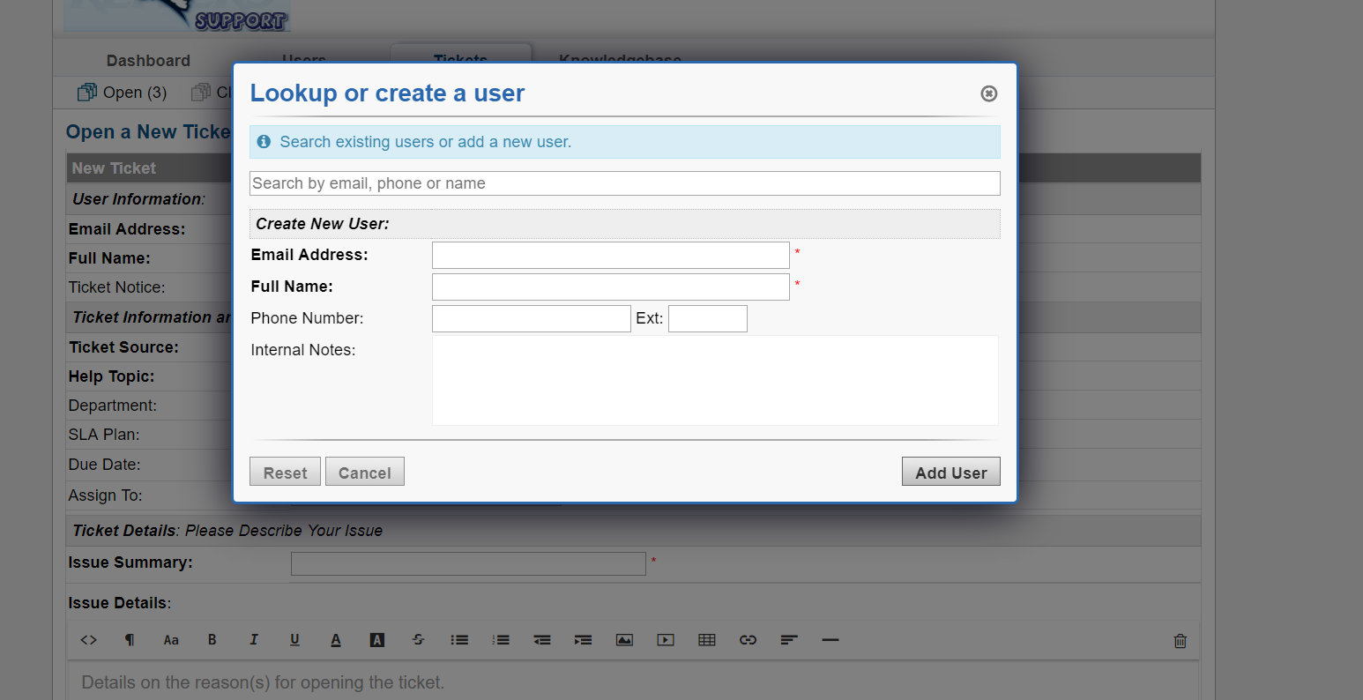

1. After you have the user created you have to create the ticket and fill out all of the information. This consists of putting in their problem, assigning it to a certain department, summarizing the issue, it will look similar to this:

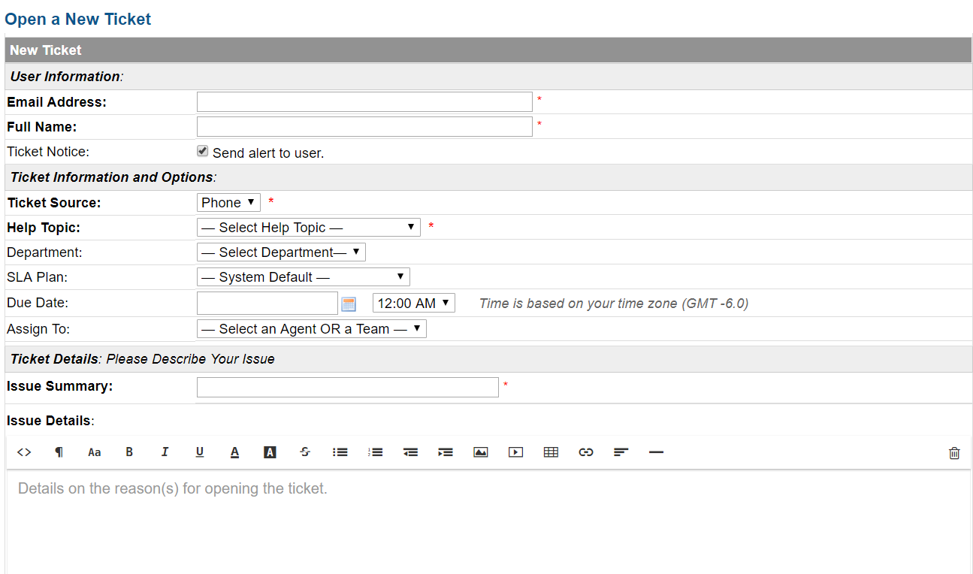

1. Once the ticket is finished you will need to email the customer and notify them that their machine is done being worked on. This is done by clicking on the ticket and going to the bottom and going to the area that looks like this:

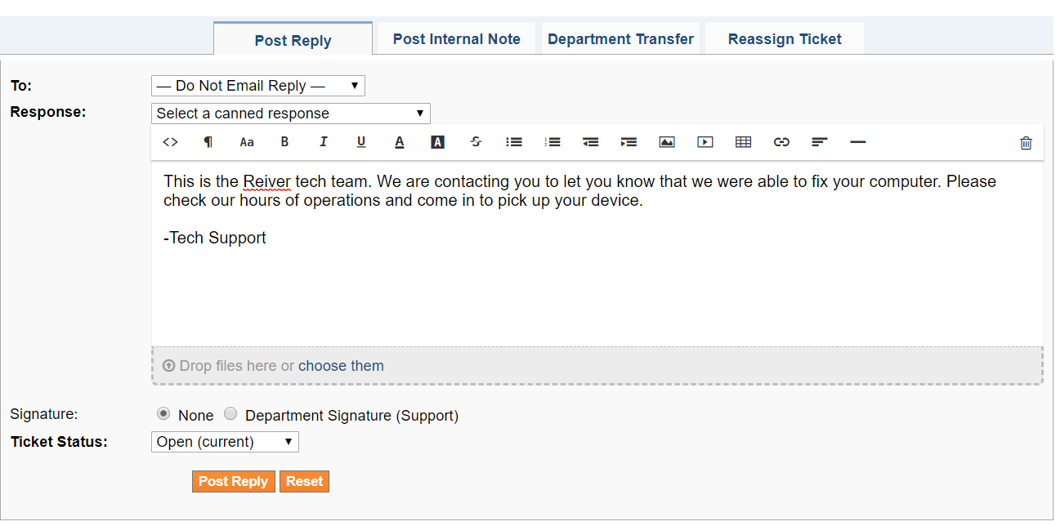

You can write your own response or select a canned one, the one used in the picture is a closing canned response.

1. Once you have your email written you will have to change the ticket to resolved in the system. This is done by going to the “Ticket Status” drop down box at the bottom of your screen. It will look like this:



You should mark it as Resolved at first, but once it is picked up by the owner you can change it to Closed.

1. You may also want to add FAQ to your company website. This can be done and should be split up into different sections. These sections could be tutorials, hardware replacement website links, virus removal software, etc. The FAQ section will look something similar to this:

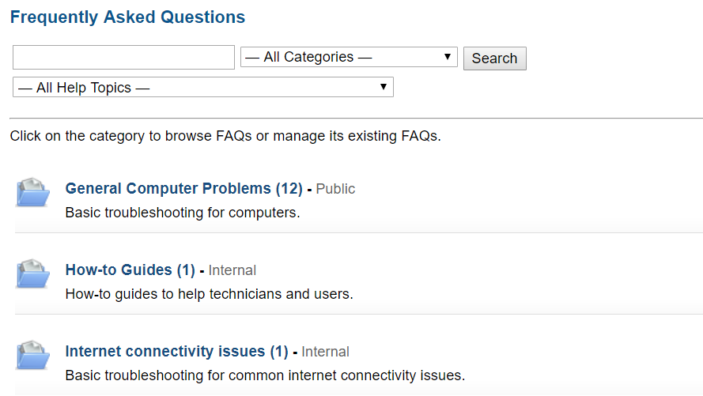

Outside Sources Cited***:***

3 Ways to Install and Run Kaspersky Rescue Disk from USB Flash Drive ? Raymond.CC [Web log post]. (n.d.). Retrieved from https://www.raymond.cc/blog/run-kaspersky-rescue-disk-10-from-usb-flash-drive/

HP G56 and G62 Laptop Screen Replacement. (2011, July 16). Retrieved from https://laptopscreensreplacement.wordpress.com/2011/07/16/hp-g56-and-g62-laptop-screen-replacement/

ITIL Checklists | IT Process Wiki. (2016, December 10). In IT Process Wiki - the ITIL® Wiki. Retrieved December 10, 2017, from https://wiki.en.it-processmaps.com/index.php/ITIL-Checklists

Page Start. (n.d.). Retrieved December 10, 2017, from https://www.pagestart.com/winxpdbwin10tp1206145.html

ISO - International Organization for Standardization. (n.d.). Retrieved from https://www.iso.org/home.html